Naan Mudhalvan Project

Voyage Vista Illuminating Insights From Uber Expeditionary Analysis

College: arignar anna government arts college for women walajapet.

Ranipet district- 632 513

Department of Mathematics



**Topic** **: Voyage Vista Illuminating Insights From Uber Expeditionary Analysis**

Submitted By

Team Leader : S.Keerthika

Team Member:

1. S.Keerthika
2. P.Lakshmi
3. T.Latchiya
4. M.Lathashree

Introduction:

**Overview**

Uber is a transportation company with an app that allows passengers to hail a ride and drivers to charge fares and get paid. It's one of many services today that contribute to the sharing economy, supplying a means of connecting existing resources instead of providing the physical resources themselves.

The company was founded by Travis Kalanick and Garrett Camp in 2009, and is headquartered in San Francisco. The company has an estimated 110 million users worldwide. This analysis can help Uber drivers decide where to focus their driving efforts for maximum efficiency and profitability. The Major of our project is to use data Analyzing techniques to find unknown patterns in the Uber Drives dataset. The research is carried out on Uber drives data collected from the year 2016.

**Objective**

Let us analyze the uber company to the data collected from 2016 . The Uber mission  is to provide transportation as reliable as running water, everywhere, for everyone. And the Uber vision is to ignite opportunity by setting the world in motion. Expandingtransportationoptions**:** Uber aims to make transportation more accessible and convenient for people around the world by providing a range of services, such as ride-hailing, bike and scooter rental, and public transportation integration.

**purpose**

Uber Driver Analysis refers to the Analyzing the number of trips taken by Uber drivers can provide insights into their overall activity and the demand for rides in specific areas. Daily, Weekly, or Monthly Analysis: Uber's data can be analyzed on a daily, weekly, monthly basis to understand the trends and patterns of trip volumes. This analysis can help identify peak hours or days of high demand and optimize driver availability during those times.

**Problem definition and design thinking:**

**Empathy map:**

An empathy map is a template that organizes a user’s behaviors and feelings to create a sense of empathy between the user and your team. The empathy map represents a principal user and helps teams understand their motivations, concerns, and experience.

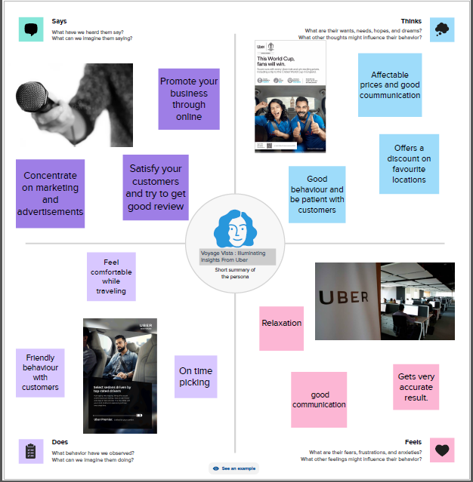

**Ideation and Brainstroming map:**

Brainstorming is simply thinking aloud and suggesting as many ideas as possible, no matter how mad they seem, without analysing or criticising them. Mind mapping is a way to get all of the ideas in your head down onto paper - a visual representation of your ideas.

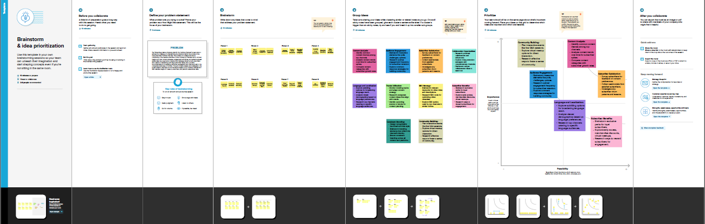

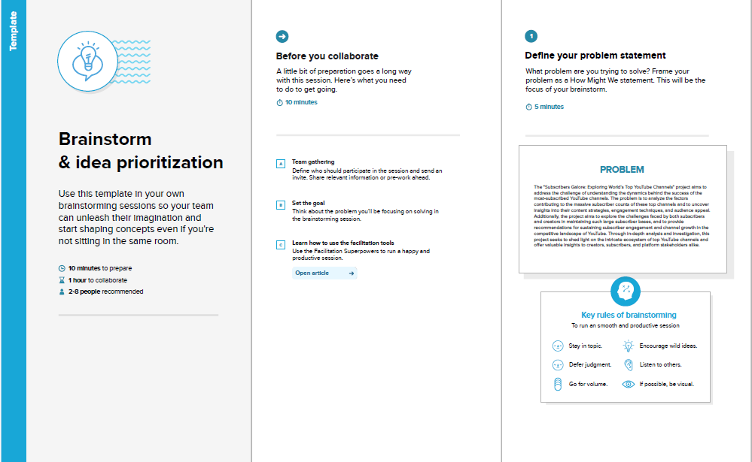

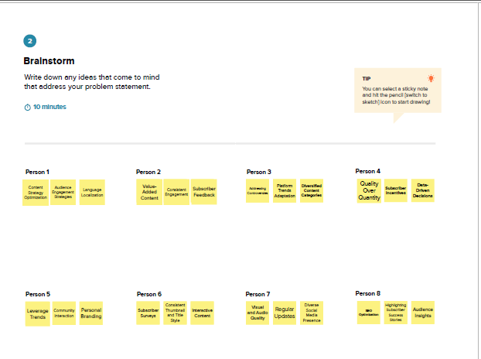

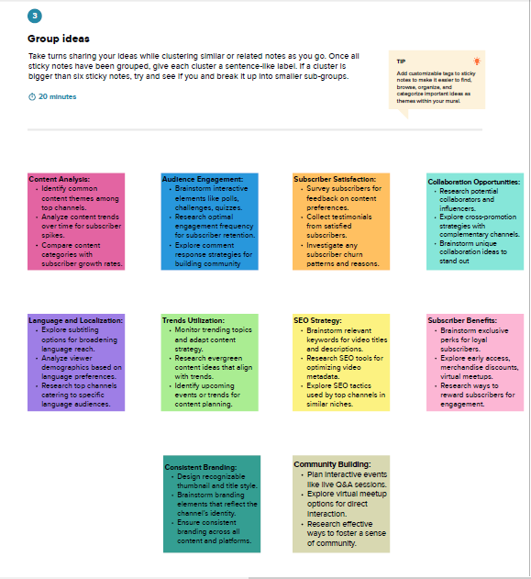

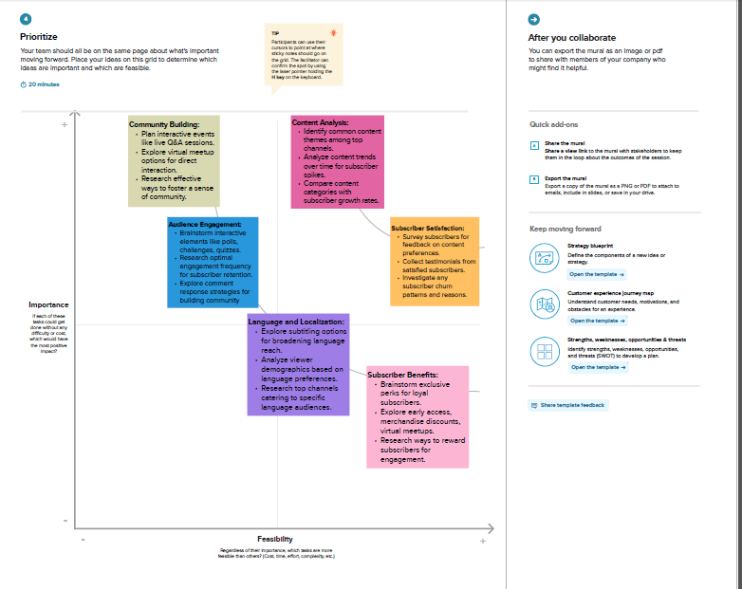

**Source of Data** :

Data is open available on Kaggle which is made available Voyage VistaIlluminating Insights From Uber Expeditionary Analysis.

https://www.kaggle.com/code/mohamed08/exploratory-data-analysis-for-uber-trips/input

**Worksheets**

1. Miles Covered per Category and Purpose.

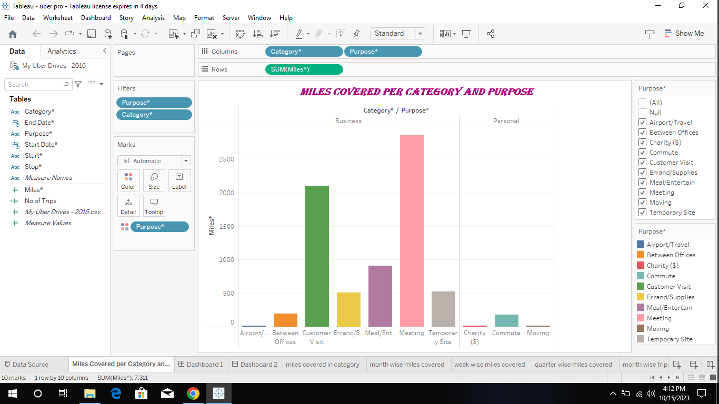

1. Miles Covered in Category.

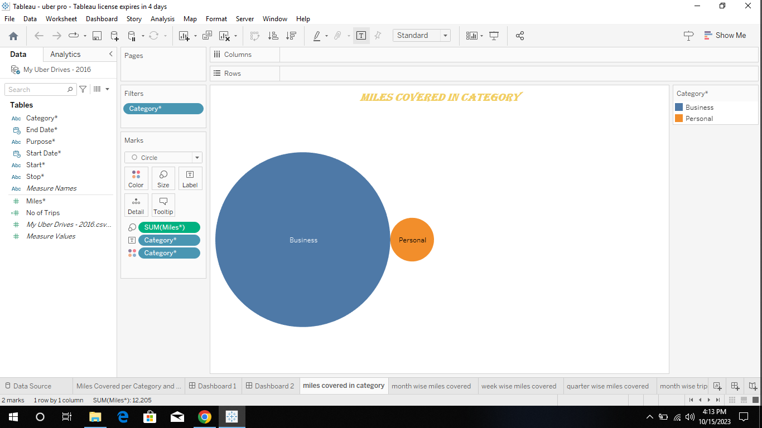

1. Month wise Uber Miles covered.

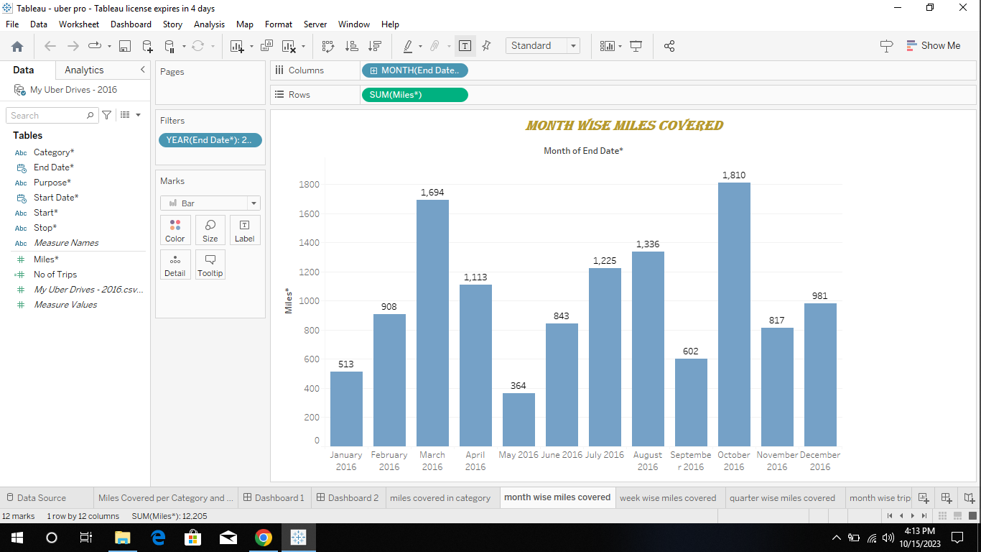

1. Week wise Uber miles covered.

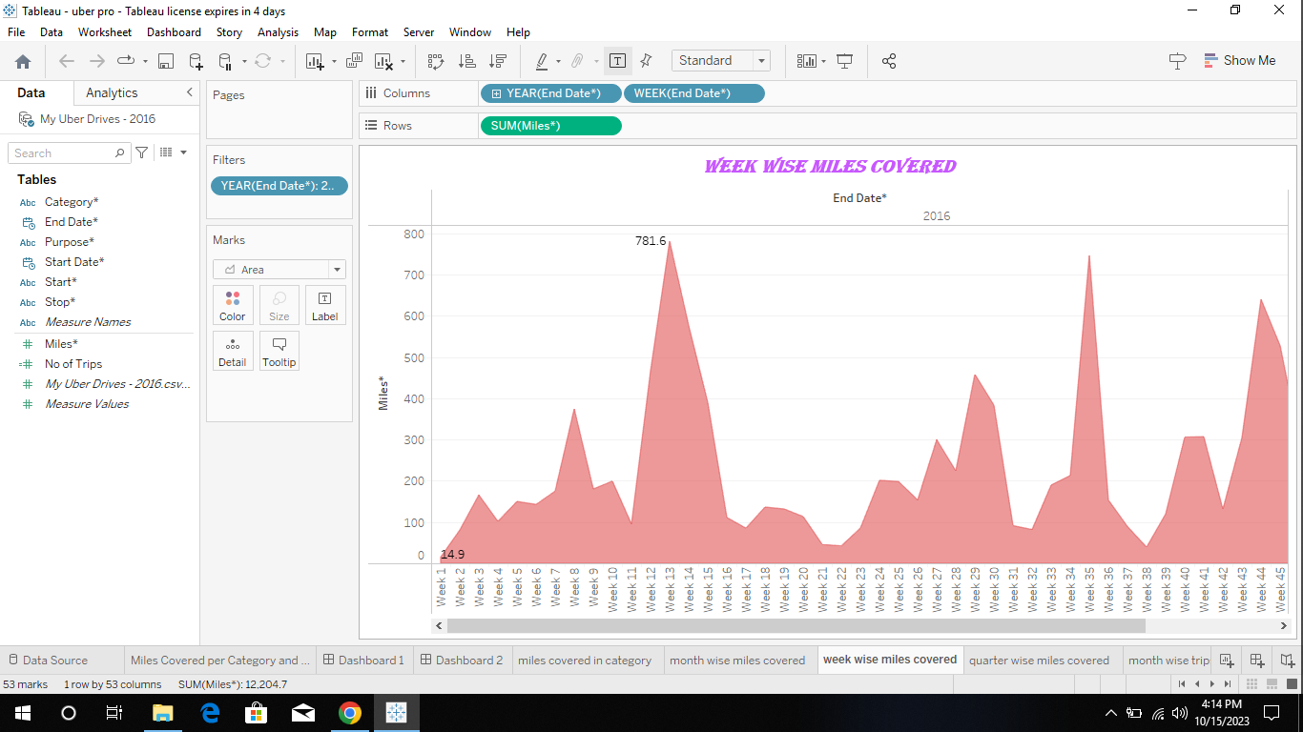

1. Quarter wise Uber Miles covered.

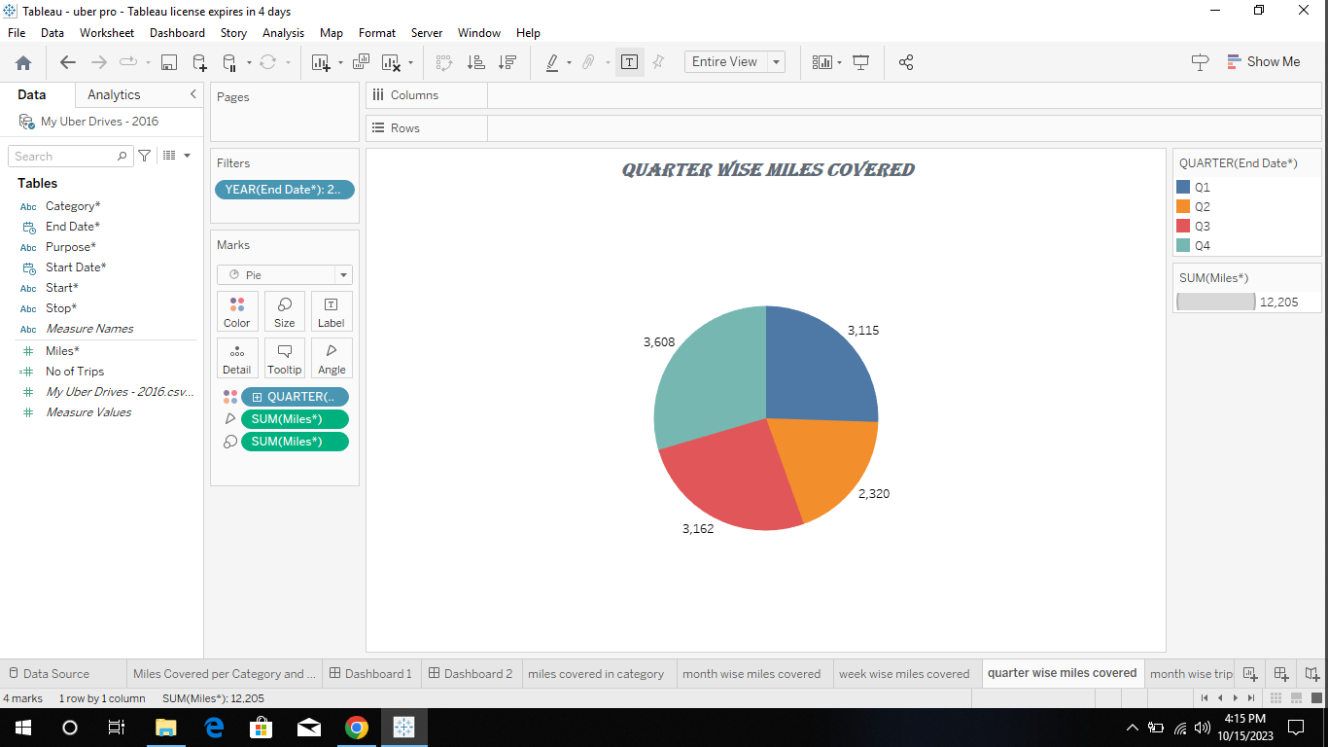

1. Month wise Uber Trips covered**.**

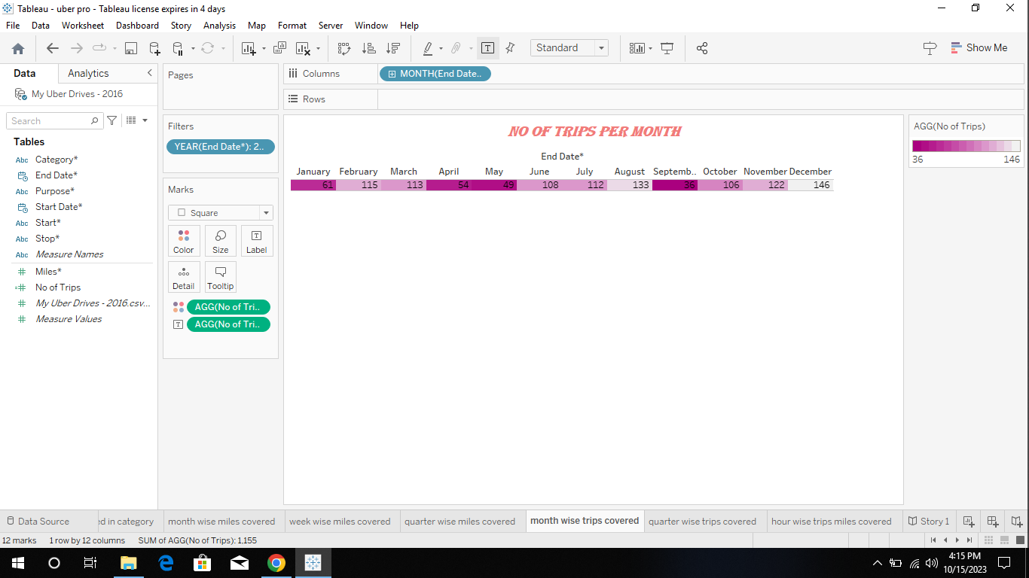

1. Quarter wise Uber Trips covered.

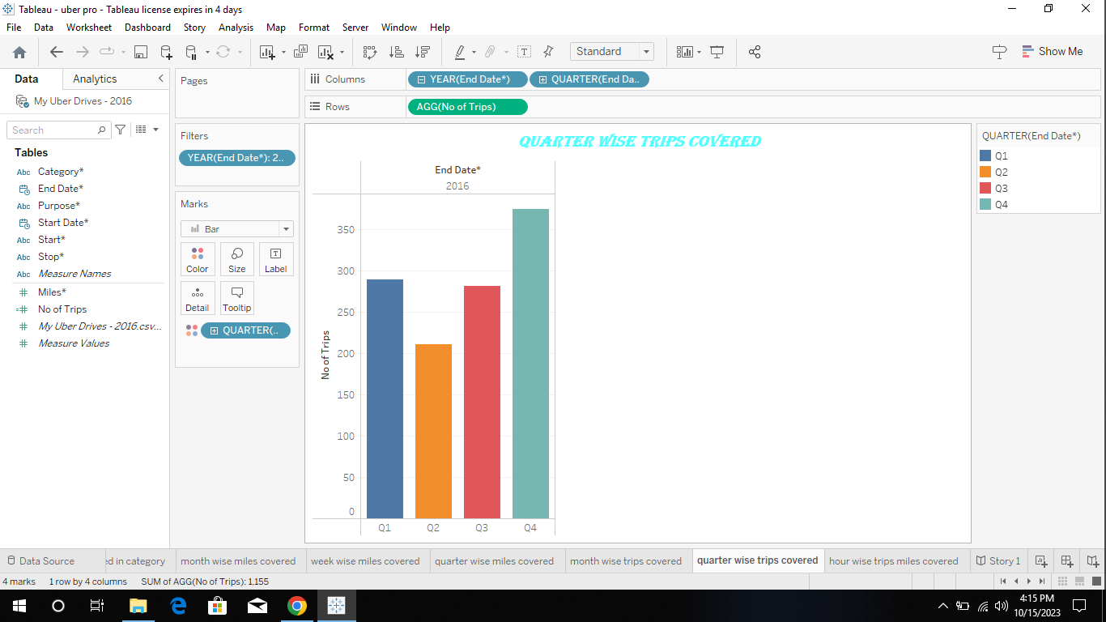

1. Hour wise Uber Trips covered**.**

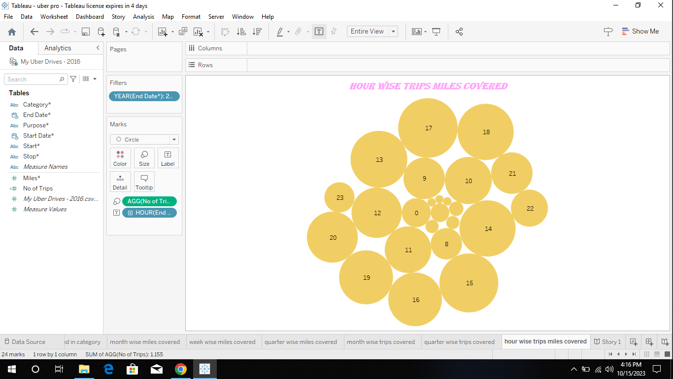

**Dashboard 1**

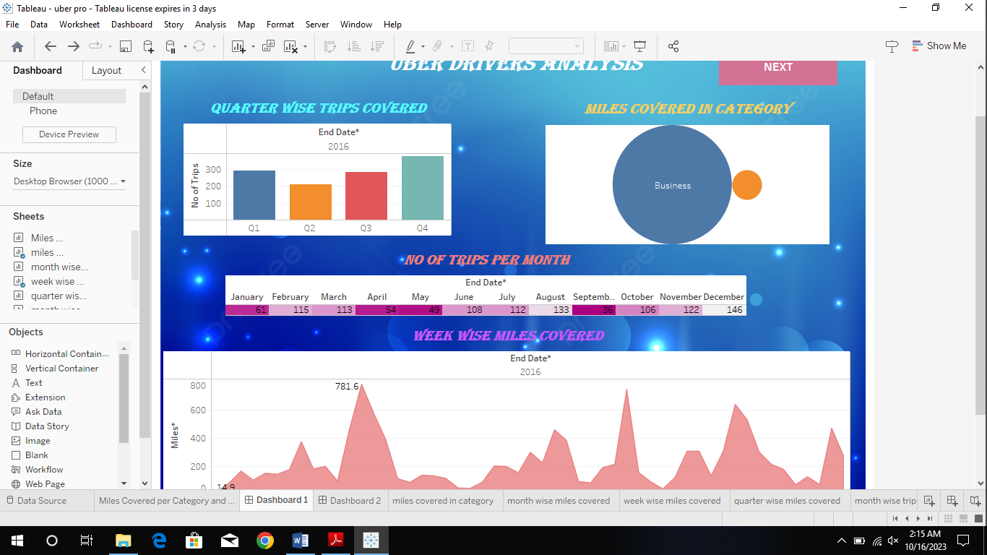

**Dashboard 2**

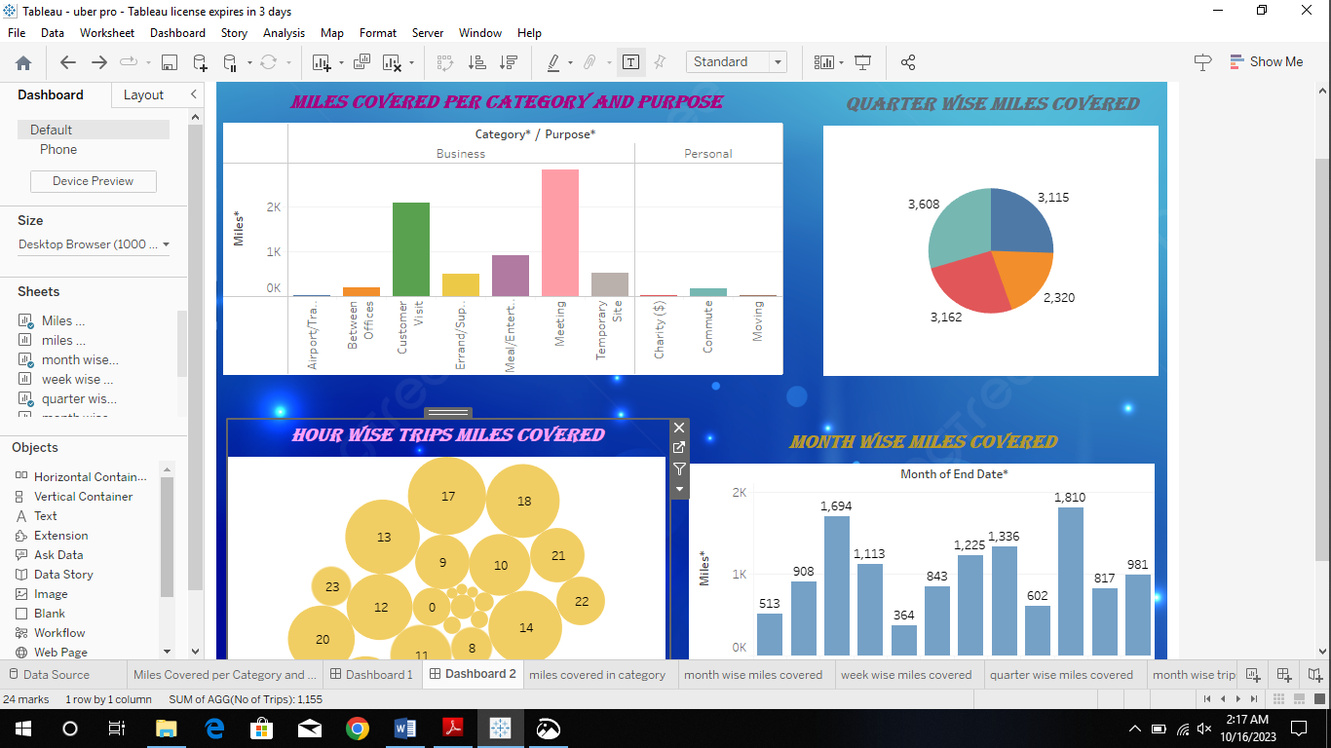

**Story:**

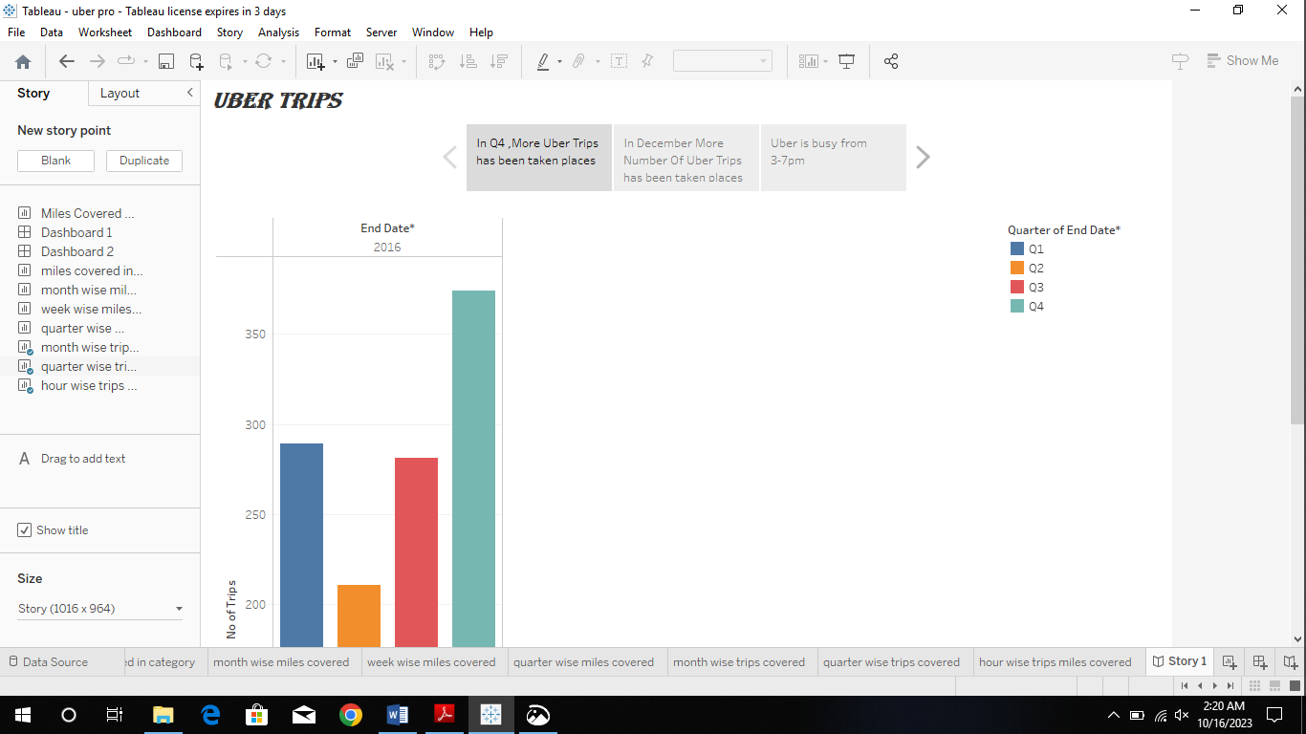

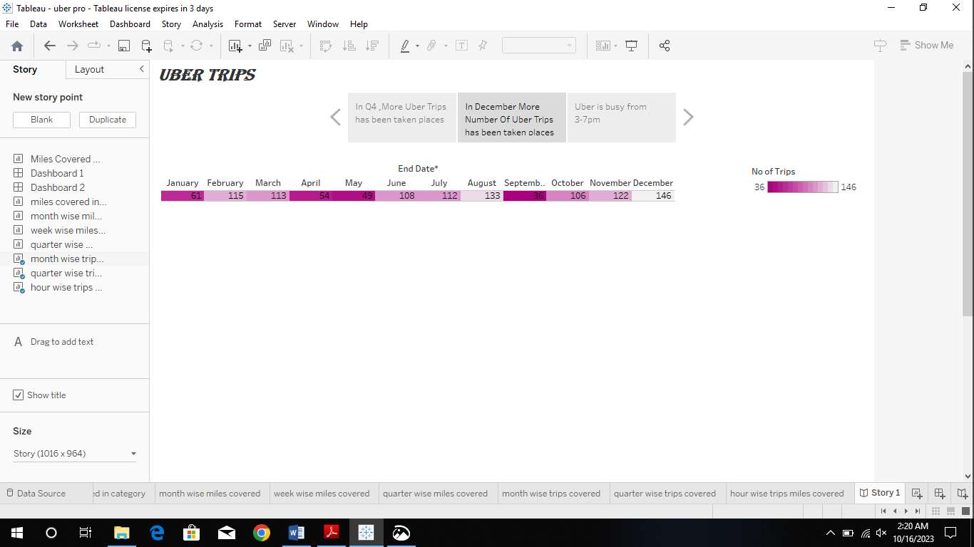

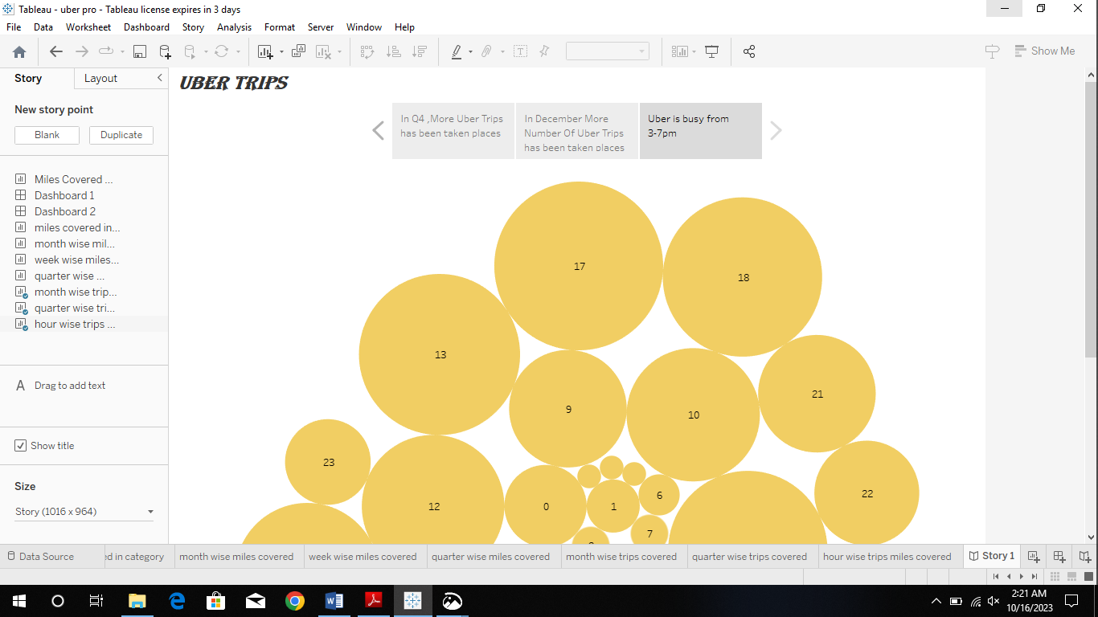

**Advantages and Disadvantages of Uber :**

**Advantages :**

Uber through E-hail has hired drivers easily and fast. Proprietary software in the app locates drivers circling nearby cheapest carpooling luxury wheels. The price is fixed.

* **Convenient and Cashless**

Instead of chasing a taxi on a street, or calling and waiting, app users can book a ride from any location and it arrives in minutes.

Passenger’s credit or debit card is linked to the taxi app account, no cash changes hands.

After the completion of the ride, A receipt is sent via email, and some links to options for rating and tipping the driver.

* **Professional Service**

Drivers for Uber may use their own cars and bike. Drivers get incentives to keep their taxis clean and well-maintained.

The cheapest options for taxis are late-model compact cars and bikes.

The riders need to insert their destinations into the app, and the drivers use the taxi app navigational features to reach the rider which is provided by the taxi app development company.

The driver talks in a polite and well-spoken manner. Drivers don't get your destination details before picking you up.

A driver with a low rating will force a driver out of Uber or its competitors.

* **Safer and Flexible**

Safety is crucial for both passengers and drivers. This is what Uber is good at it. It is one of the major advantages of Uber. The riders are registered their identities and their payment channels. Cashless transactions also make it safer, a driver and rider don’t need to carry cash.

**Disadvantage:**

Drivers are not assured of minimum pay to maintain their own vehicles. This topic is growing controversial in many cities because New York City mandated a $17.22 minimum wage for drivers.

* **Surge Pricing**

“Surge pricing” or “rush time pricing” is not fixed in uber. It’s a free market principle of raising prices according to supply and demand.

This means how many taxis are available (supply) and how many customers want to ride(demand).

This automated system sometimes shows differences in pricing between any two same points.

At peak times, the price could be double or more. This means too costly during rush hour.

Although this benefits uber by increasing the supply of drivers. Drivers can be motivated to earn at this time.

* **Low Fares WorryDrivers**

Some Uber drivers say they struggle to earn minimum wage. Drivers have to pay the cost of fuel, maintenance, and repairs from their own pocket.

With competition from other taxi apps, the earnings of drivers can be driven downward.

This indicates that they need to work for longer hours to earn a certain income.

* **Price Competition**

Uber and other taxi-hailing companies are engaged in an intensive fight to provide the most affordable service.

They are competing with traditional taxi services for both customers and drivers. This has led to low earnings for taxi drivers.

**Future scope:**

Sometimes, it is hard to realize what to expect from such companies like Uber that have been developed within a short period of time and become successful at the international level. The evaluation of its potential future business issues is unpredictable. Still, it is possible to offer several ideas.

For example, one of its co-founders, Kalanick believes that Uber has all chances to spread its services in the way it can be more effective to be the Uber’s passenger than to own a car (Shontell, 2015). In fact, the prospects described by the owners of the company and the abilities help to realize that the future of the company can be successful.

It is possible to provide people with taxi services for affordable prices around the whole world. Even the point that some people want to travel without drivers does not create a problem for the company. Kalanick thinks about the possibility to provide people with taxi services without chauffeurs (Shontell, 2015).

It is expected that people learn more about Uber and want to have such services available in their towns. It is possible for the company to think about the possibility to offer its services in small towns. The access to the Internet is possible in villages nowadays. That is why it should not cause a problem for a person to register and become a passenger of Uber within a short period of time. Still, the business issues that can be developed in the nearest future are connected with the possibility to have more countries and towns being involved.

It is also possible to have more benefits due to the possibility to offer diverse services of various qualities. Passengers with various incomes can use Uber. Another potential issue is the cooperation with huge international companies. The question of comfortable and appropriate transportation rises in a number of companies. Business people want to be sure in the services they order. That is why Uber can offer taxi for people as well as cargo transportation around the whole world.

**Conclusion:**

In general, the example offered by Uber can be used by many developing companies. Nowadays, it is not a difficult task to create an organization and introduce some new, unusual services. However, it is always challenging to gain a good reputation, prove the quality of the services, and create appropriate working conditions.

Uber is the company with a complicated history. Still, its founders had made something that was impossible: they survived sabotages, strikes, and discontents of the governments of different countries around the whole world. The necessity to provide people with good services at affordable prices is urgent nowadays. Not all people are able to use the quality they want. Uber opens new perspectives and possibilities.

However, its attempts to cooperate with big cities only are not enough to become one of the best. It is necessary to make more improvements and encourage changes. Drivers are eager to work at different places. Uber can provide drivers with jobs and citizens with transportation services. The factors for success and challenges discussed in the current paper show that Uber as all chances to succeed in international marketing. The only thing that the company has to do is to continue developing and thinking about its employees.